# Overview

In November 2022 Horse + Bamboo were awarded ongoing National Portfolio Funding from Arts Council England to continue our work with communities in Rossendale and the North West, our early years engagement programme, our residencies in prisons with dads and their families and the development of artists and audiences in our venue in Waterfoot, Rossendale.

This funding came with an uplift to develop our new Creation Centre making an accessible, open, creative space for artists to make work, particularly theatre, to hone their craft and to train others. Over the coming years we will also be working on the company archive, establishing a resource with national significance which tells a large part of the story of theatre-making in Rossendale and Lancashire.

It is an exciting time for a company with clear vision and momentum as we work towards our 50th anniversary in 2028.

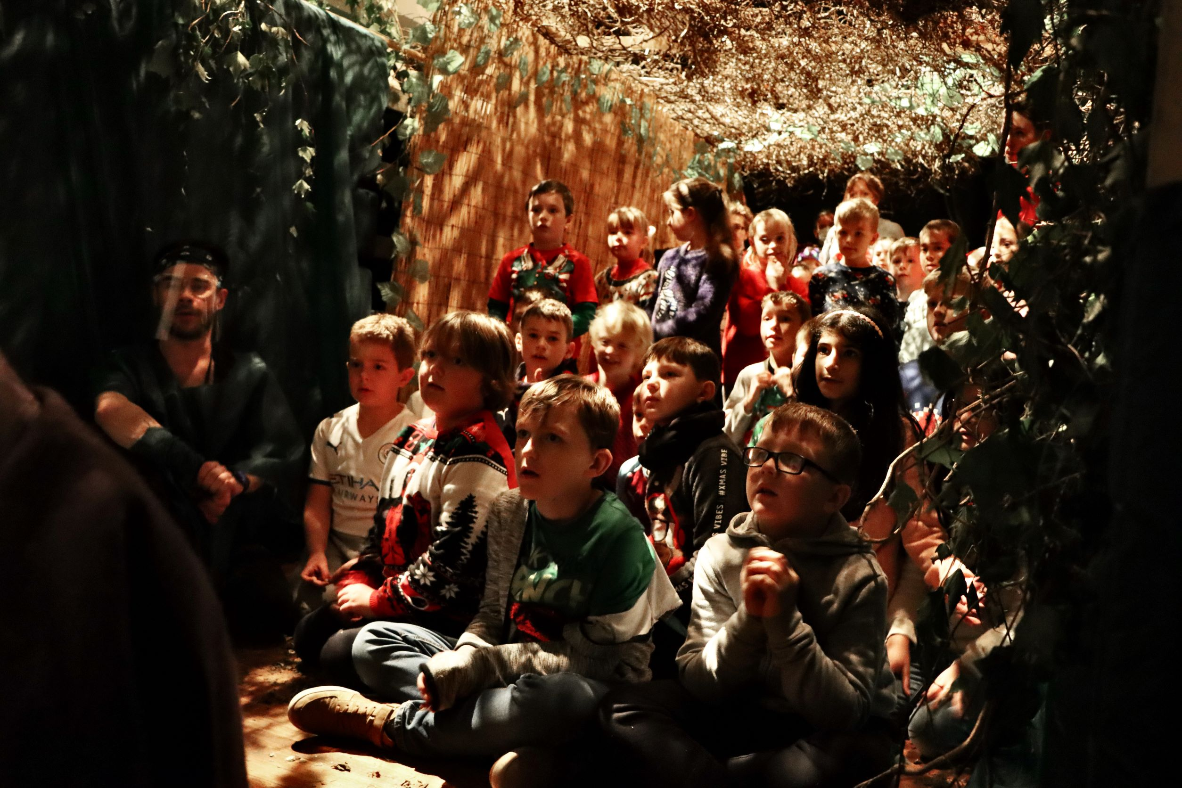

## History

Horse + Bamboo has been in the Rossendale Valley since 1978. Our purpose was to take visual, musical and predominantly non-verbal theatre to places largely neglected by conventional forms of theatre, playing to audiences from a wide range of backgrounds. The name derives from the use of horses to pull a caravan when touring, which was a central feature of the company's work from 1979 to 1999.

Horse and Bamboo continued to tour in a more conventional manner throughout the first two decades of the 21st century, maintaining its roots in rural touring through small, flexible shows for community venues throughout the country.

From 2005 onwards the company opened the doors of its base in Waterfoot, originally the village’s Liberal Club, to serve as a centre and venue for the company's local community in Pennine Lancashire. This venue has become increasingly well used by the neighbourhood and by theatre and music groups touring nationally and is now establishing its new Creation Centre for creatives and theatre-makers.

## Vision

Horse + Bamboo creates exciting, cultural events that remind us all of the wonder of being alive in this endlessly fascinating world. We aspire to reach all sections of society and to respond and listen to the needs of our surrounding communities in Rossendale and the North-West. We will be a vital part of our neighbourhood, creating a place where the seed of creativity can be planted, fed and nurtured.

## Mission

We draw inspiration from our location in Rossendale and reflect our sense of place in the events that we produce. We are part of the cultural fabric of our neighbourhood through our venue and outreach and we celebrate and actively reflect its rich diversity. Our venue provides a sense of belonging, a place for inspiration and a welcoming environment where experiences are shared through theatre, music and film.

We are a leader in Folk Art and define this in its broadest sense, from young people creating videos and dance on TikTok and other digital platforms, to the folklore of the many global communities that have chosen Lancashire as their home, to the traditional arts and dance of Lancashire’s historic communities. We are interested in gathering community stories but seek to do this in a way that considers the ethics and authenticity of our role and which credits and cares for all contributors and fellow creators. We are always redefining what this means in practice so as to reflect the role of new technologies and community created content in folk art alongside traditions, folklore and ceremony.

Within our building we also house our Creation Centre, a space for artists to collaborate, create and share their work. It comprises a rehearsal room and fully-equipped making workshop alongside technical and digital capacity to research, develop and fully realise creative ideas.

Our extensive archive highlights four decades of visual theatre, national and international touring, processional arts, puppetry, music and mask. This provides us with a bedrock of inspiration from which to continuously grow new work, which is connected to, not limited by, our illustrious history.

## Our core values

* Everyone is creative
* Our cultural lives matter. They are vital to who each of us is. It is a human right.
* We will not allow lack of finance to limit participation.
* We take our civic responsibility seriously.
* We will show leadership in environmental sustainability within our organisation and in developing partnerships.

# Attributes of a trustee

* Commitment to the work of Horse + Bamboo
* A resonance with our vision, mission and values
* Understanding of the legal duties, responsibilities and liabilities of trusteeship
* Enthusiasm for arts, culture and heritage.
* Strategic vision and ability to think creatively.
* Good independent judgment.
* Experience of business planning, financial or project management
* Ability to work as a member of a team and willingness to state personal convictions and, equally, to accept a majority decision and be tolerant of other views
* To provide advice and support to senior staff as relevant and appropriate
* Commitment to Nolan's seven principles of public life: selflessness, integrity, objectivity, accountability, openness, honesty and leadership.

## Benefits of becoming a trustee

* Networking opportunities
* Active involvement in a creative hub at the heart of the community
* Opportunity to actively support and guide the organisation and be part of work that reaches, benefits and influences a wide range of groups and stakeholders.
* Complementary tickets and opportunities for you and your family to access shows, workshops etc

## Eligibility

Some people are disqualified by law from acting as a trustee including anyone who:

* Has an unspent conviction for an offence involving deception or dishonesty
* Is an undischarged bankrupt
* Has been removed from trusteeship of a charity by the Courts of the Charity Commission for misconduct or mismanagement
* Has been disqualified from being a company director under the Company Directors Disqualification Act 1986.

## Terms of Appointment

* No remuneration will be made, but travel and out-of-pocket expenses can be reimbursed where required.
* Board meetings (4 per year) ‘emergency’ meetings and Annual General Meetings (which coincide with Board meetings) plus sub-group meeting as may be possible. Board meetings are held at Horse + Bamboo, Waterfoot, Rossendale, usually on a Wednesday at 6.30pm and 3 of 4 meetings per year can be accessed online.
* Meeting dates for 2025 are –

*Wed 22nd Jan 2025 – AGM & Board*

*Wed 16th April 2025*

*Wed 2nd July 2025*

*Wed 22nd Oct 2025*

How to apply:

Please send an email to [info@horseandbamboo.org](mailto:info@horseandbamboo.org) explaining why you are interested in being a Trustee and outline what skills and experience you could bring to the role.

We would also be happy to organise a meeting to speak to your further about what being a Trustee at H&B initials.

We are specifically looking for someone with experience in financial management and fundraising.